
GLOBAL NEXT CONSULTING INDIA PRIVATE LIMITED GNCIPL
Data Analytics Week-1 Project Based on Basic Excel.
Ramkrishna Ghosh
Project Title : (24) Ocean Plastic Pollution Mapping
STEM area : Environmental Science / Marine Biology
Description : Collect location data of plastic pollution; SQL to store;
Excel quantify burden
Key Excel Skills : SQL geospatial; Excel charts & maps

Ocean Plastic Pollution Mapping

Column Name | Meaning
Location | Name of the ocean region where plastic samples were recorded (e.g., Pacific Ocean, Indian Ocean).
Latitude & Longitude | Exact GPS coordinates of sample collection.  Help to visually map pollution
Plastic_Tonnage_Tons | Estimated amount of plastic found in that region (in tons).
Plastic_Type | Type of plastic found such as Microplastics, Fishing Nets, Bottles, Packaging Waste, etc.  Helps understand what kind of waste is most responsible. Important
Collection_Year | Year when the sample or measurement was taken.  Needed to observe trends over time
Pollution_Source | Major contributing source like Household Waste, Shipping Routes, Fishing Industry, Tourism, etc.
Distance_From_Coast_km | How far from the nearest coastline the sample was taken (in kms).  Helps analyze how plastics travel, ocean currents impact, and to compare coastal vs deep ocean pollution.
Severity_Level | Category such as Low, Medium, or High based on plastic tonnage and environmental impact.  Helps to make classification

1) Pollution by Ocean
SELECT Location, SUM(Plastic_Tonnage_Tons) AS Total_Pollution
FROM ocean_pollution
GROUP BY Location;
Insight :
- We can spot the most polluted ocean and the least polluted one.
- Helps us compare pollution levels across different oceans.
Recommendations:
- Focus immediate cleanup and monitoring efforts on top polluted oceans.
- Implement waste management policies and stricter dumping regulations for coastal regions near those oceans.

2) Pollution by Plastic Type
SELECT Plastic_Type, SUM(Plastic_Tonnage_Tons) AS Total_Waste
FROM ocean_pollution
GROUP BY Plastic_Type;
Insight :
- which types of plastic are contributing most to pollution.
- Helps understand waste source type
Recommendations:
- Target high-pollution plastic types with recycling programs, bans, or biodegradable alternatives.
- Encourage companies to shift from single-use plastics to eco-friendly packaging.

3) Pollution Trend by Year
SELECT Collection_Year, SUM(Plastic_Tonnage_Tons) AS Yearly_Tonnage
FROM ocean_pollution
GROUP BY Collection_Year;
Insight :
- How pollution changed over years
- To analyze whether pollution is increasing or decreasing over time
- Useful for environmental forecasting and policy evaluation
Recommendations:
- If pollution is increasing, enforce stricter marine waste regulations and stronger penalties.
- If pollution is decreasing, analyze what policies worked and expand them.

4) Pollution by Source Industry
SELECT Pollution_Source, SUM(Plastic_Tonnage_Tons) AS Total_Tons
FROM ocean_pollution
GROUP BY Pollution_Source;
Insight
- Which identify major contributors or activities cause the pollution
- Helps pinpoint responsible sectors (fishing, shipping, tourism, households).
Recommendations:
- Develop industry-specific pollution control guidelines.
- Set up waste collection and treatment units near ports, fisheries, and tourist coastlines.

5) Severity Level Distribution
SELECT Severity_Level, COUNT(Severity_Level) AS Region_Count
FROM ocean_pollution
GROUP BY Severity_Level;
Insight
- To categorize regions into high, medium, low pollution zones.
- Makes it easier to visualize risk zones to cleanup and conservation efforts.
Recommendations:
- High severity regions: Allocate immediate cleanup operations and government funding.
- Medium severity regions: Begin preventive measures before it escalates (awareness, waste bins, shoreline monitoring).
- Low severity regions: Maintain strict conservation rules so they don’t worsen.

6) Identify the Most Heavily Polluted Points (Top 10 )
SELECT location, latitude, longitude, plastic_tonnage_tons
FROM ocean_pollution_database
ORDER BY plastic_tonnage_tons DESC
LIMIT 10;
Insight :
- The most polluted coordinates.
- Helps locate critical cleanup target zones.
Recommendations:
- Deploy cleanup teams, ocean booms, and waste extraction systems at these hotspots.
- Conduct field investigations to identify local contamination sources.

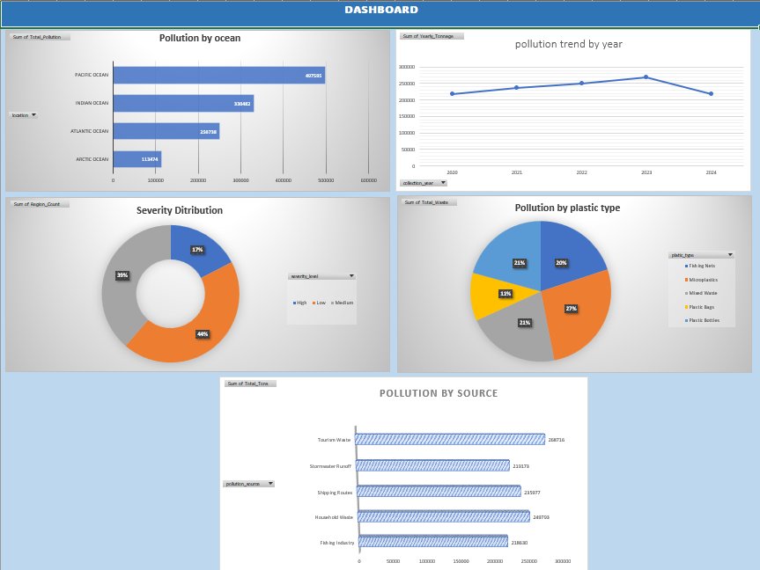
DASHBOARD :

